# List of tables

|  |  |  |  |
| --- | --- | --- | --- |
| **SR**  **NO.** | **Table Name** | **Type of Table** | **Row Count** |
| 1 | DimAccount | Dimension | 24 |
| 2 | DimChannel | Dimension | 4 |
| 3 | DimCurrency | Dimension | 28 |
| 4 | DimCustomer_Company | Dimension | 386 |
| 5 | DimCustomer_Person | Dimension | 18,484 |
| 6 | DimDate | Dimension | 45,656 |
| 7 | DimEntity | Dimension | 421 |
| 8 | DimGeography | Dimension | 517 |
| 9 | DimProduct | Dimension | 2,517 |
| 10 | DimProductCost | Dimension | 27,060 |
| 11 | DimProductPrice | Dimension | 29,568 |
| 12 | DimPromotion | Dimension | 28 |
| 13 | DimSalesTerritory | Dimension | 265 |
| 14 | DimScenario | Dimension | 3 |
| 15 | DimStore | Dimension | 306 |

**Performance Statistics Of Talend DI**

|  |  |  |  |  |
| --- | --- | --- | --- | --- |
| **SR NO.** | **Table Populated** | **Number of**  **Inserts (Talend)** | **Number**  **of Rejects** | **Time taken (in Seconds)** |
| 1 | DimAccount | 24 | 0 | 0.687 sec |
| 2 | DimChannel | 4 | 0 | 0.639 sec |
| 3 | DimCurrency | 28 | 0 | 0.703 sec |
| 4 | DimCustomer_Company | 386 | 0 | 1.4 sec |
| 5 | DimCustomer_Person | 18,484 | 0 | 1.9 sec |
| 6 | DimDate | 45,656 | 0 | 3.1 sec |
| 7 | DimEntity | 306 | 0 | 1.5 sec |
| 8 | DimGeography | 517 | 0 | 1.4 sec |
| 9 | DimProduct | 2,517 | 0 | 2.0 sec |
| 10 | DimProductCost | 27060 | 0 | 610.1 sec |
| 11 | DimProductPrice | 29568 | 0 | 535.5 sec |
| 12 | DimPromotion | 28 | 0 | 1.4 sec |
| 13 | DimSalesTerritory | 265 | 0 | 1.5 sec |
| 14 | DimScenario | 3 | 0 | 0.5 sec |
| 15 | DimStore | 306 | 0 | 1.6 sec |
| 16 | FactExchangeRate | 2,192 | 0 | sec |
| 17 | FactSalesQuota | 3,839,378 | 4,68,557 | sec |
| 18 | FactStrategyPlan | 2,017,741 | 0 | sec |
| 19 | FactInventory | 9,270,723 | 210,650 | sec |
| 20 | FactOnlineSales | 3,820,218 | 9,76,238 | sec |
| 21 | FactSales | 883,292 | 41,819 | sec |
|  | **Master_Job** | - | - | **720.0 sec**  **~ 18 min** |

**Talend Screenshots**

1. DimAccount

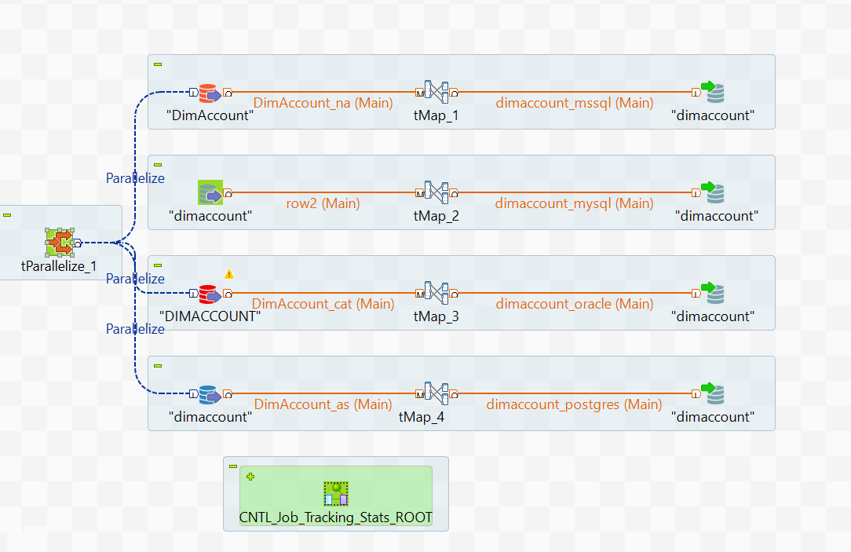

1. DimChannel

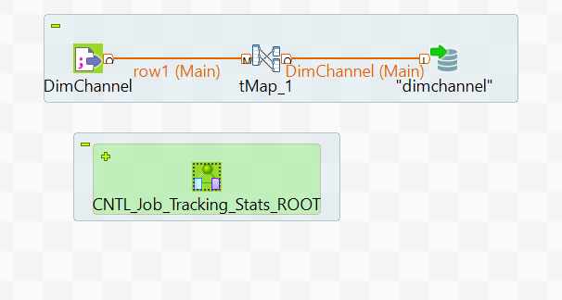

1. DimCurrency

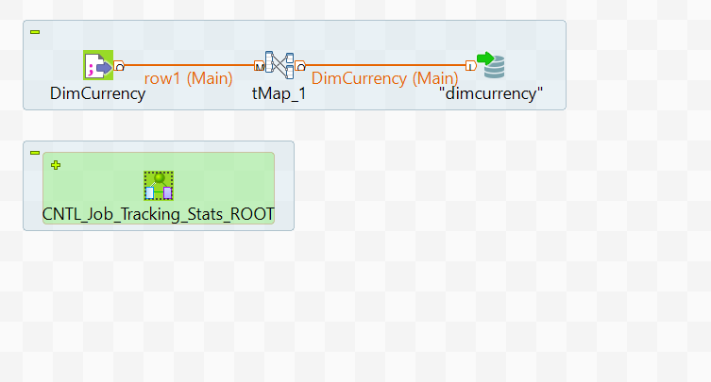

1. DimCustomer_Company

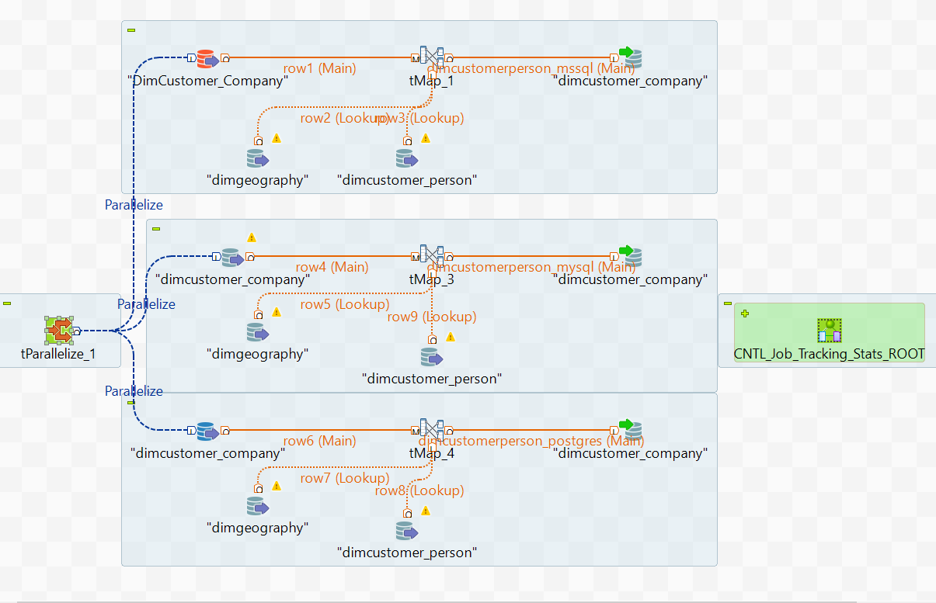

1. DimCustomer_Person

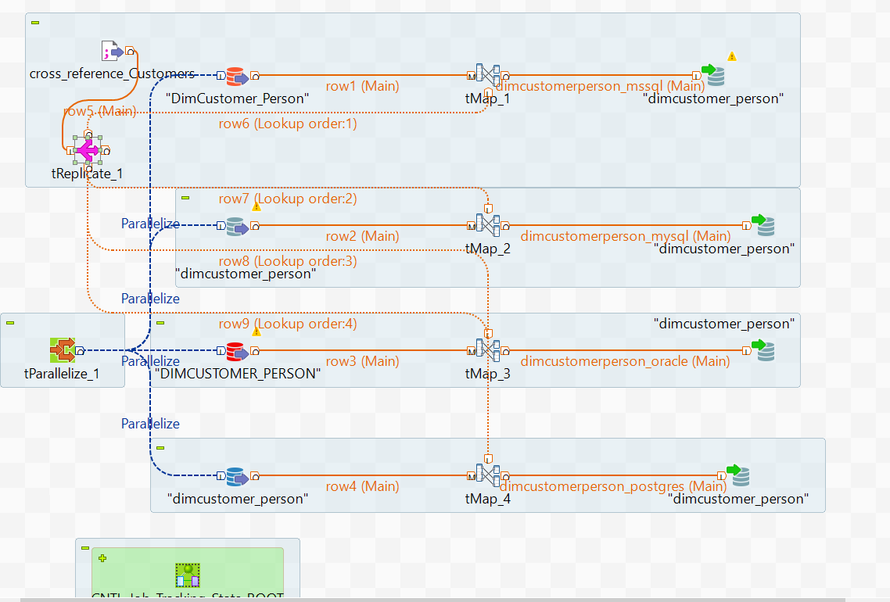

1. DimDate

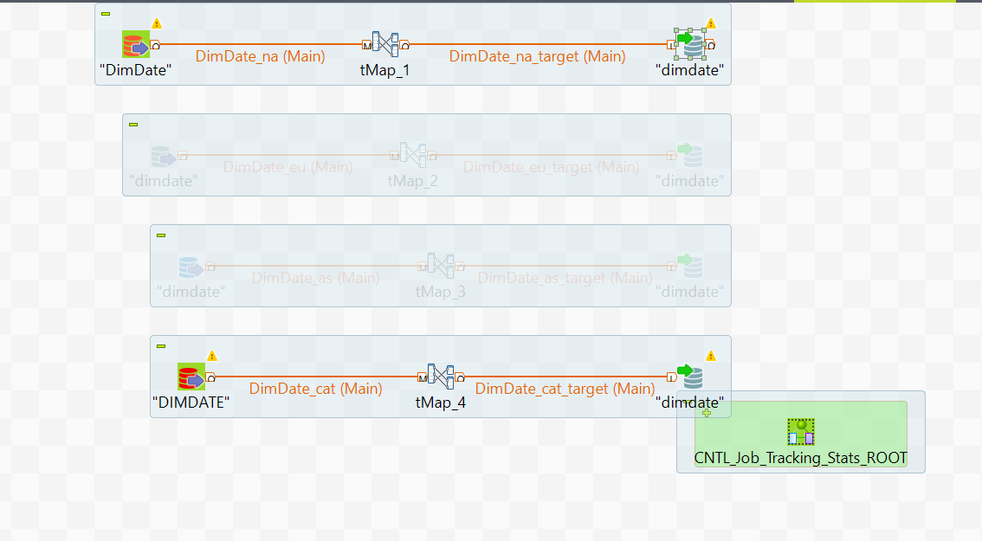

1. DimEntity

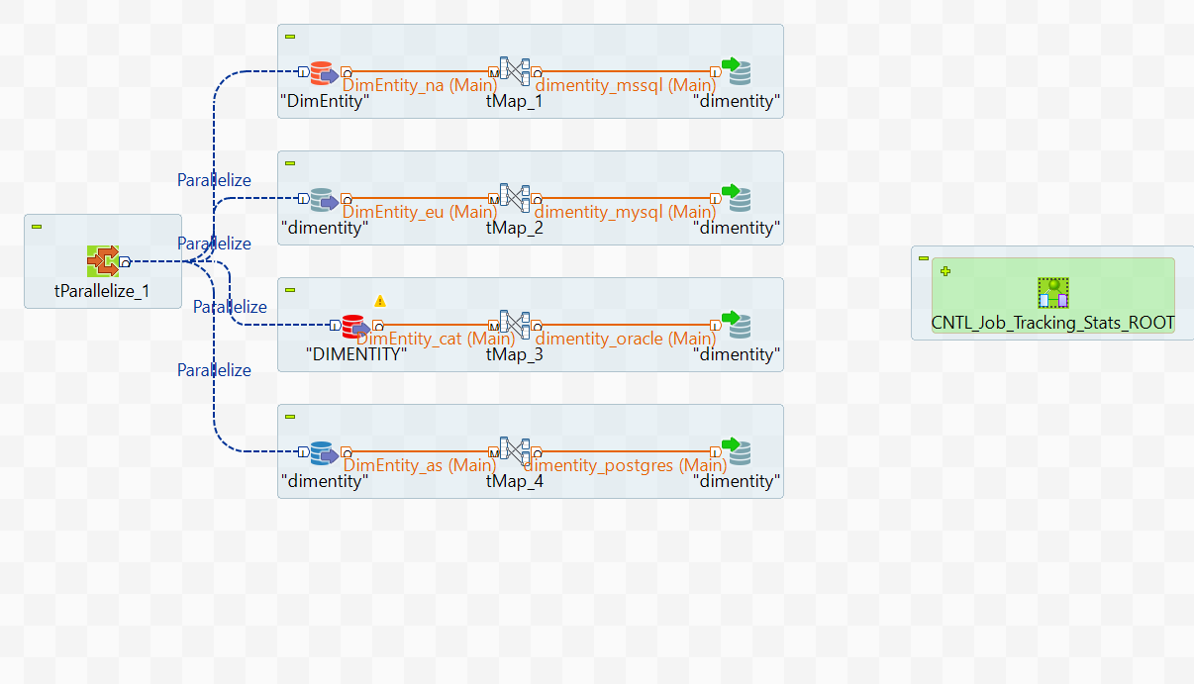

1. DimGeography

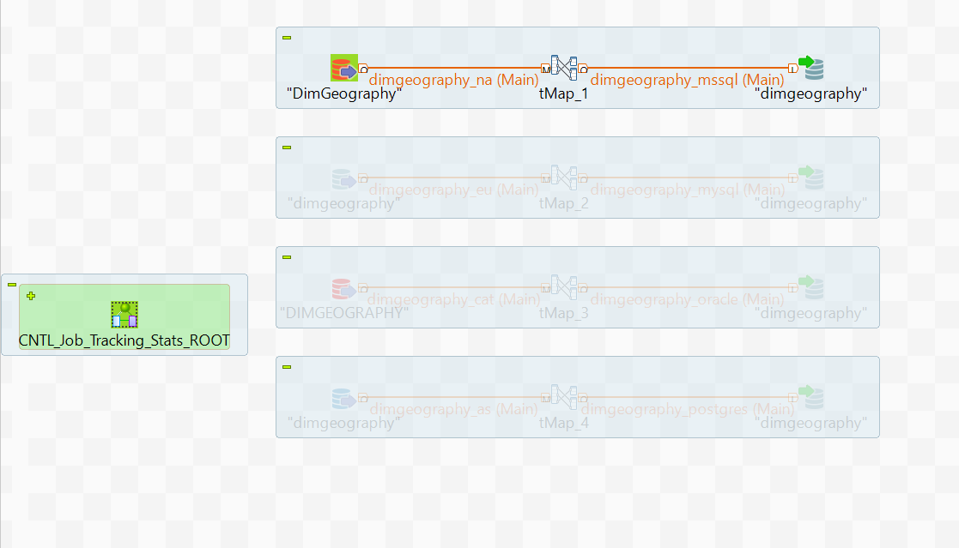

1. DimProduct

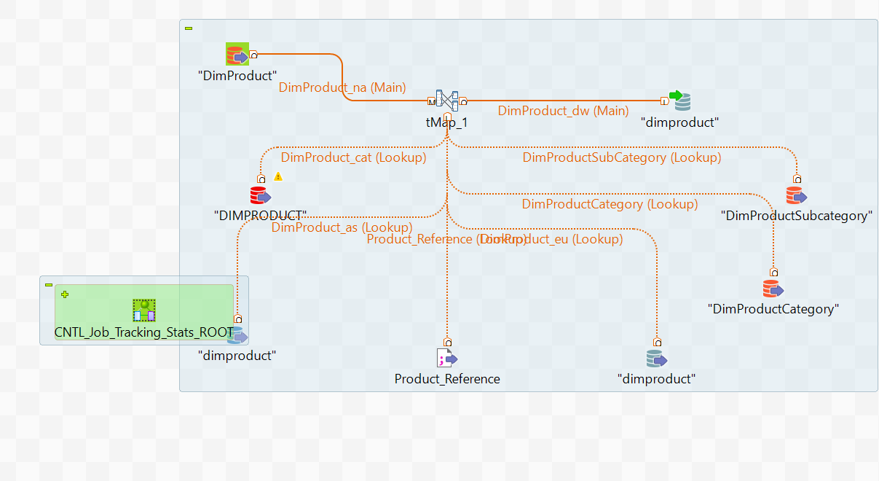

1. DimPromotion

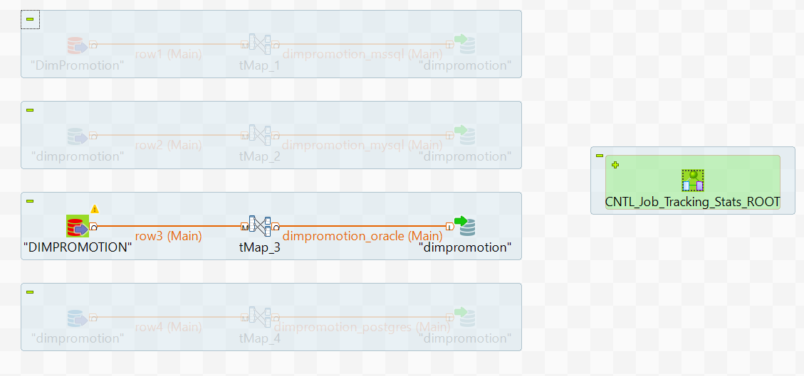

1. DimSalesTerritory

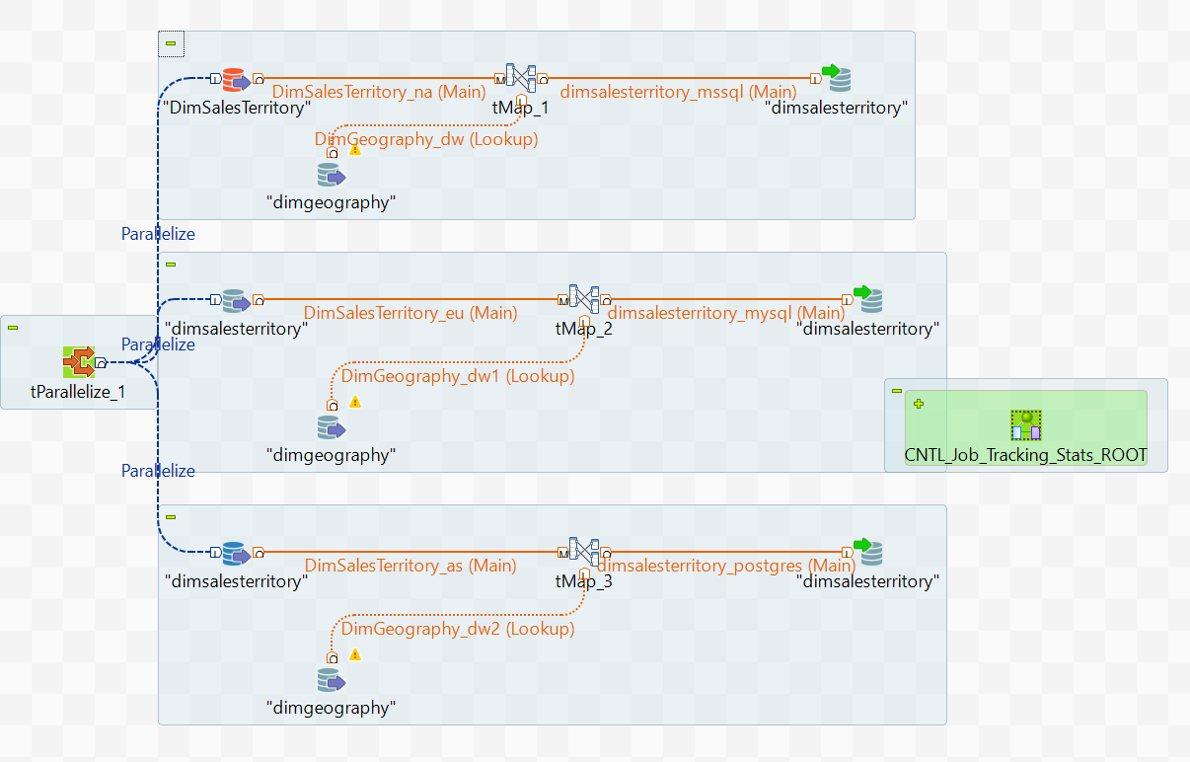

1. DimScenario

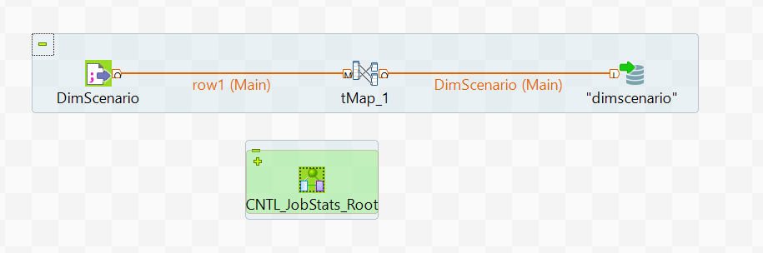

1. DimStore

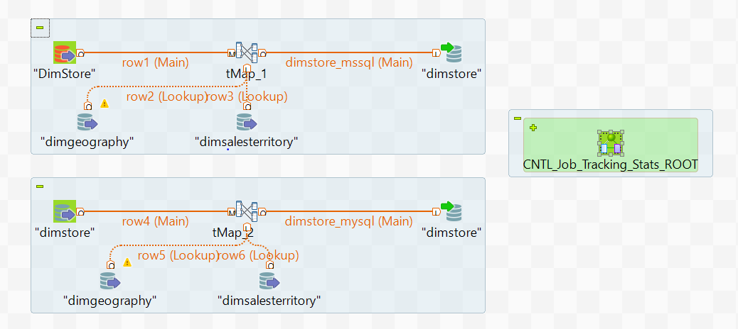

1. FactExchangeRate

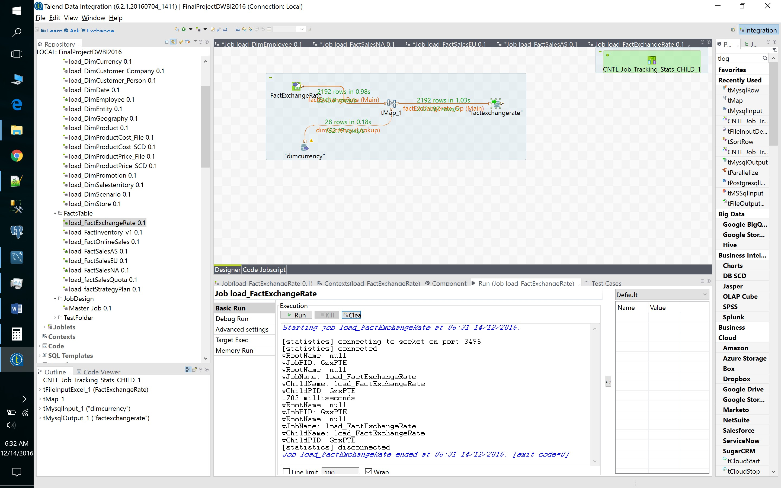

1. FactStrategyPlan

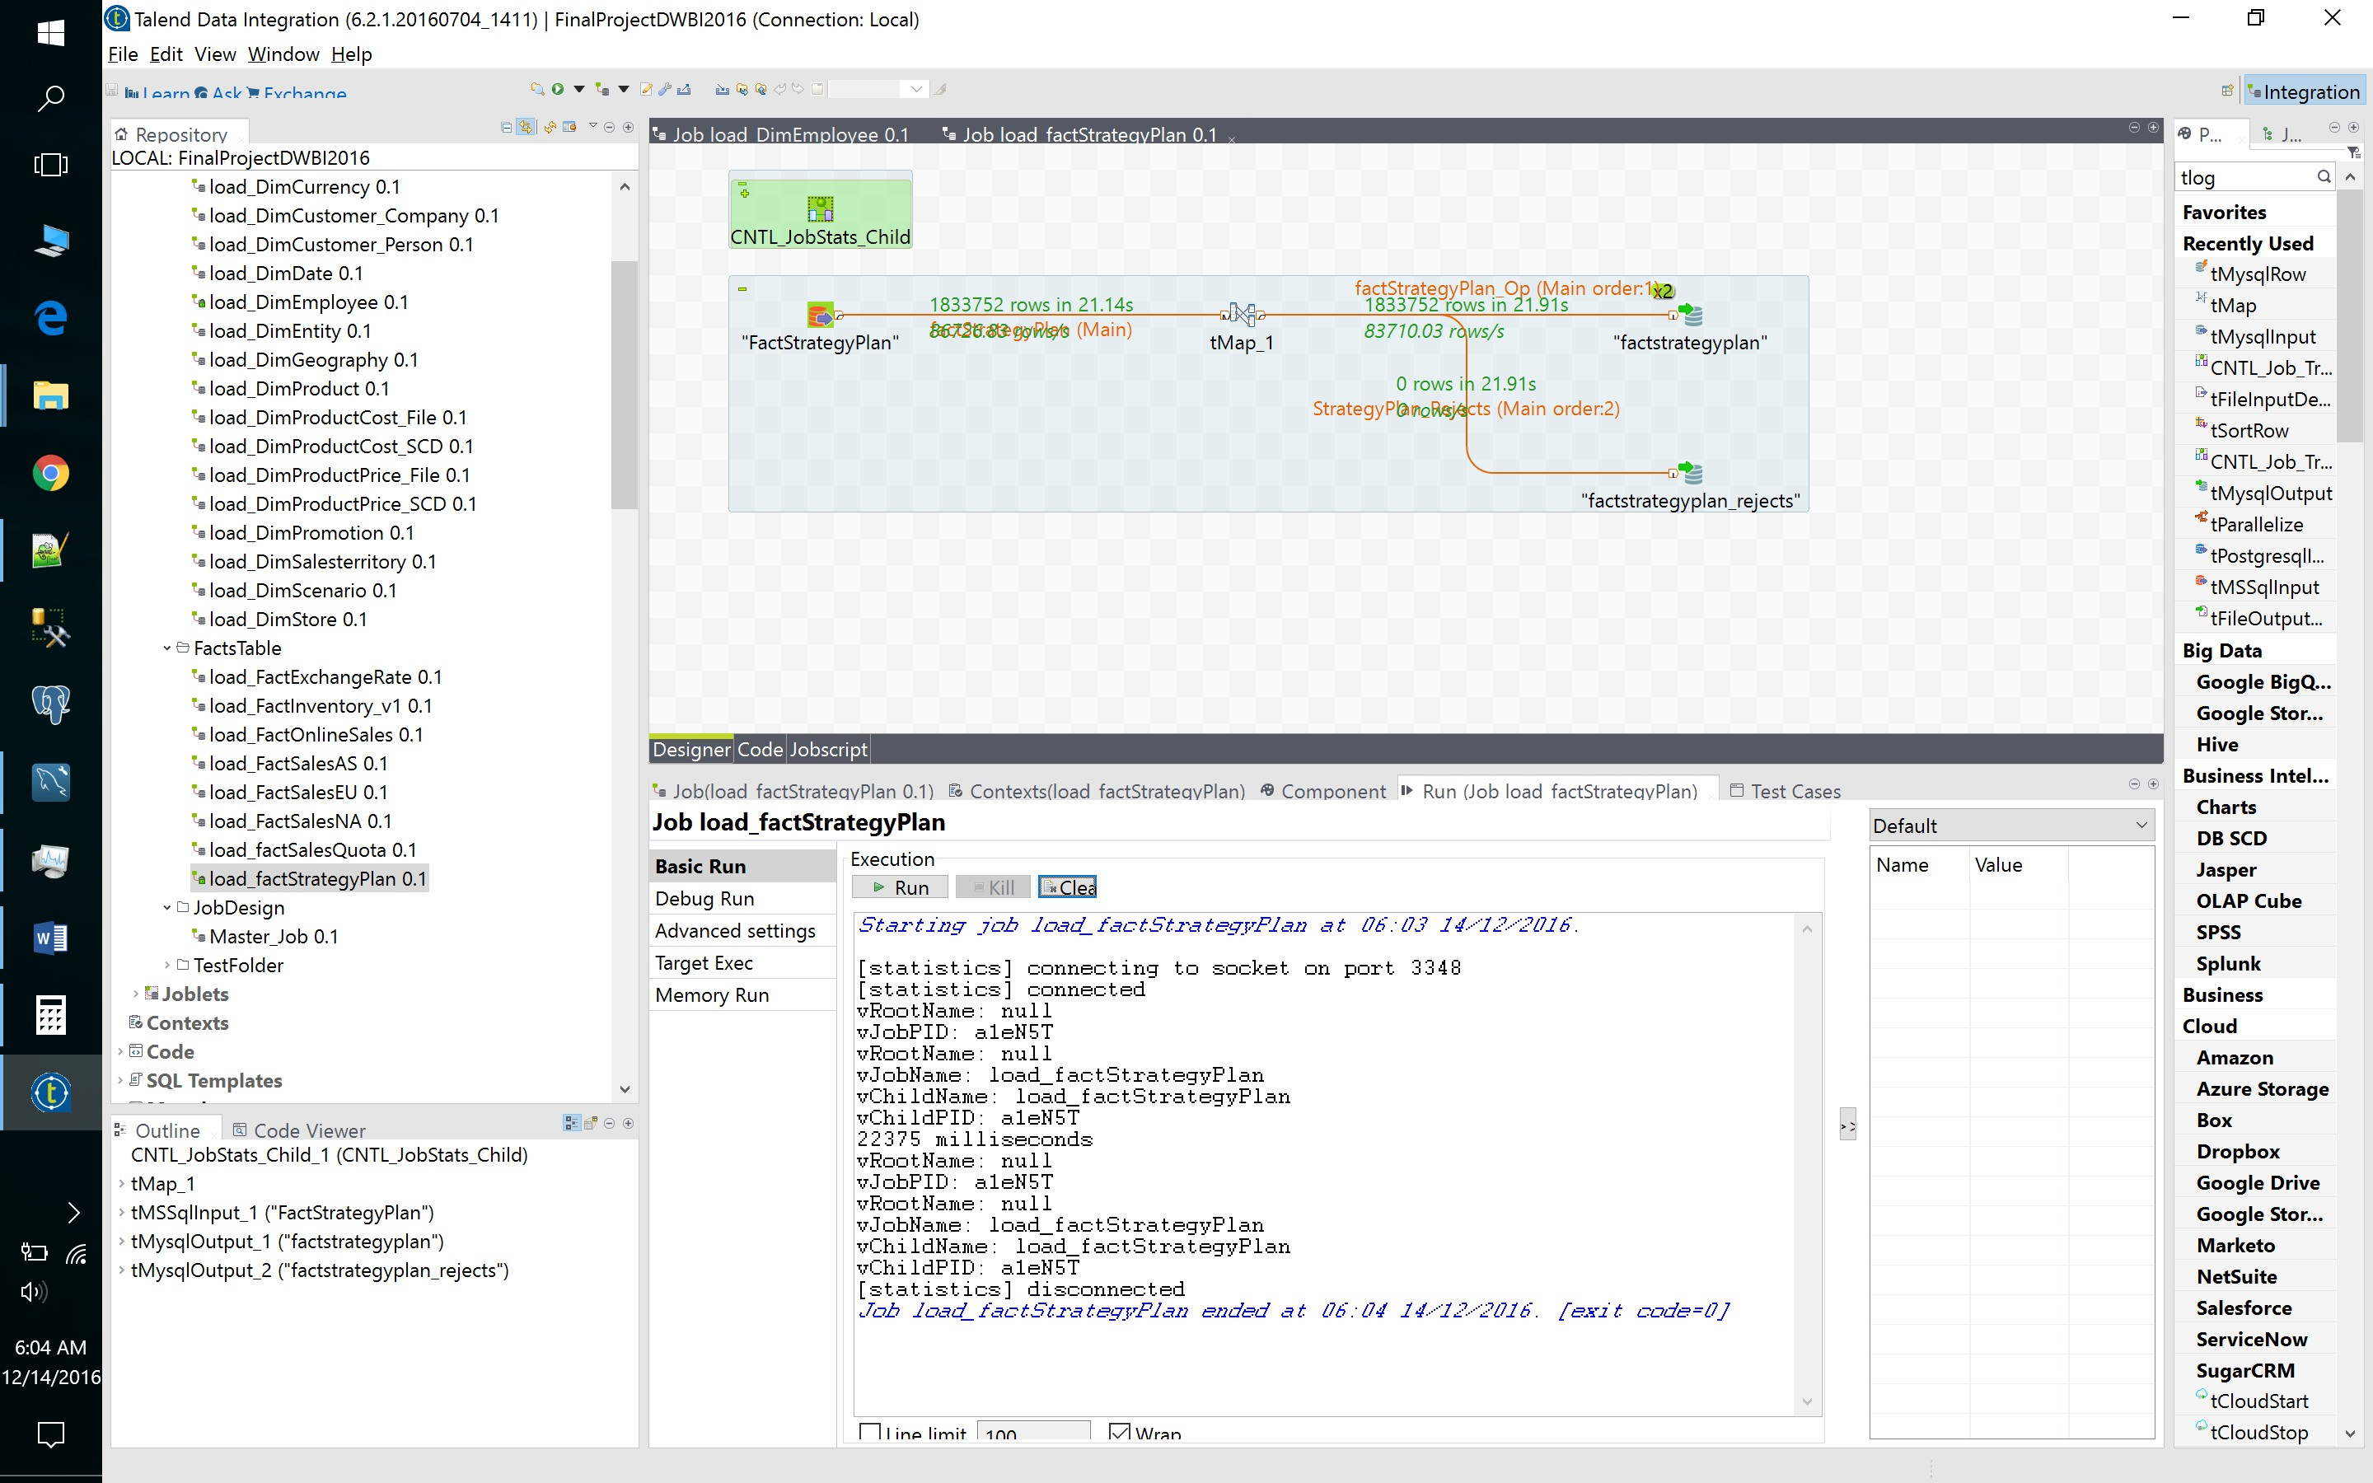

1. FactProductInventory

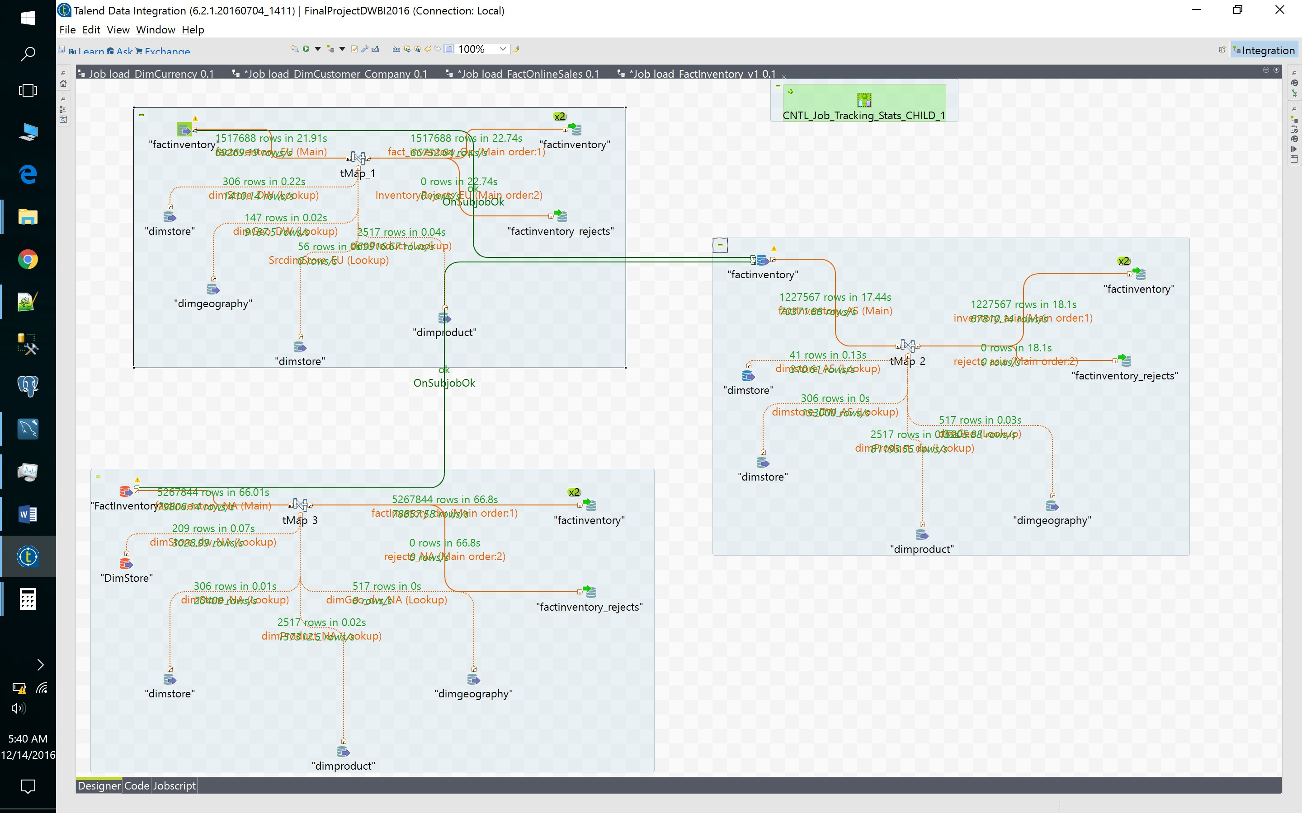

1. FactSalesQuota

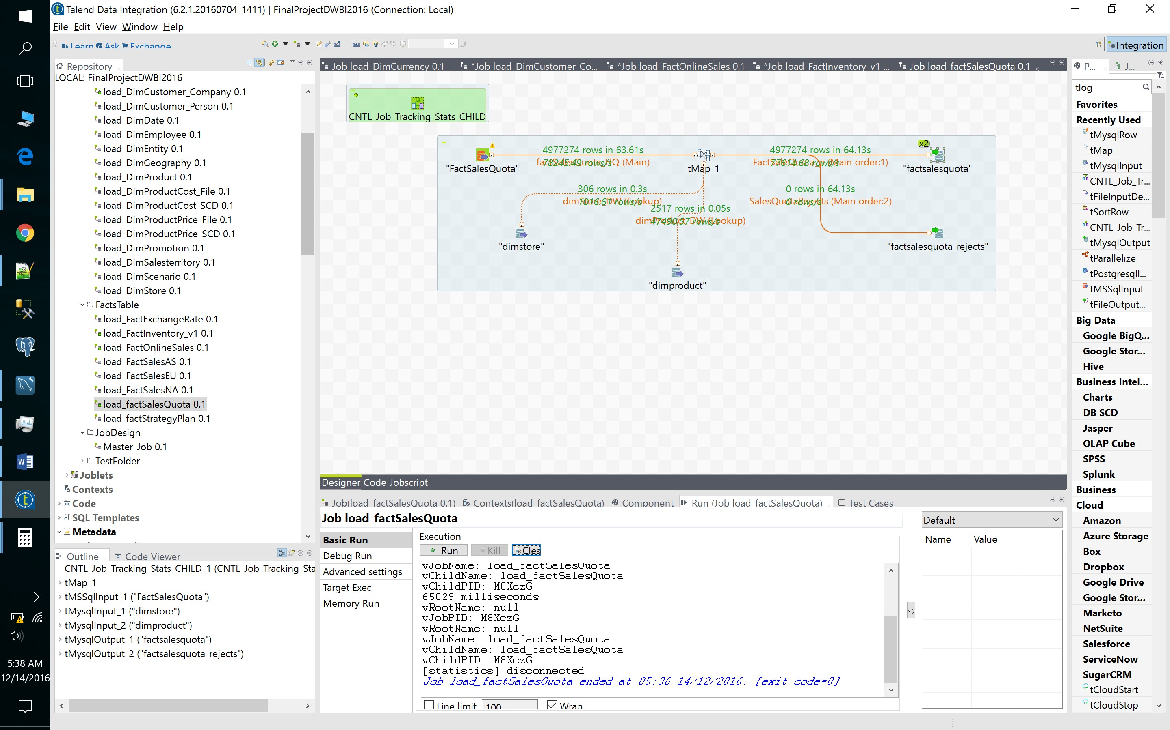

1. FactOnlineSales

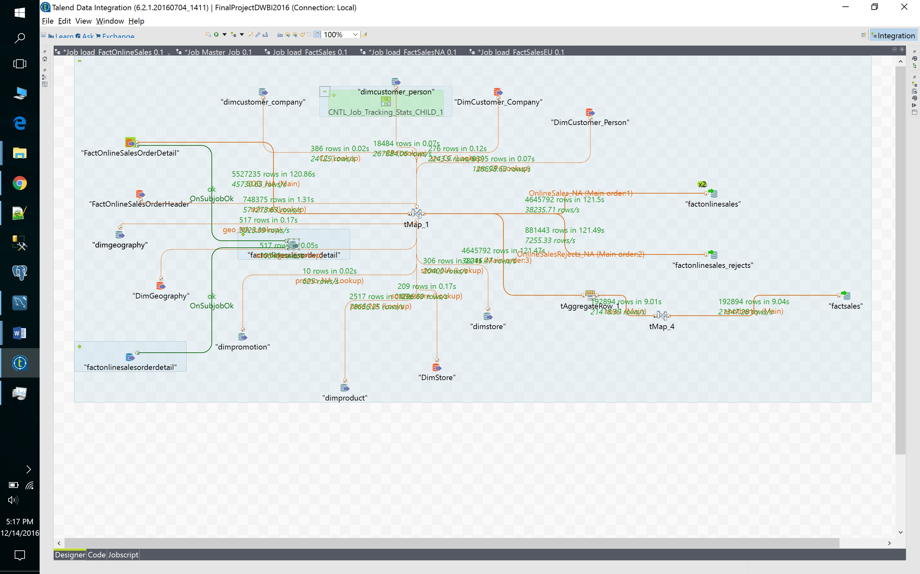

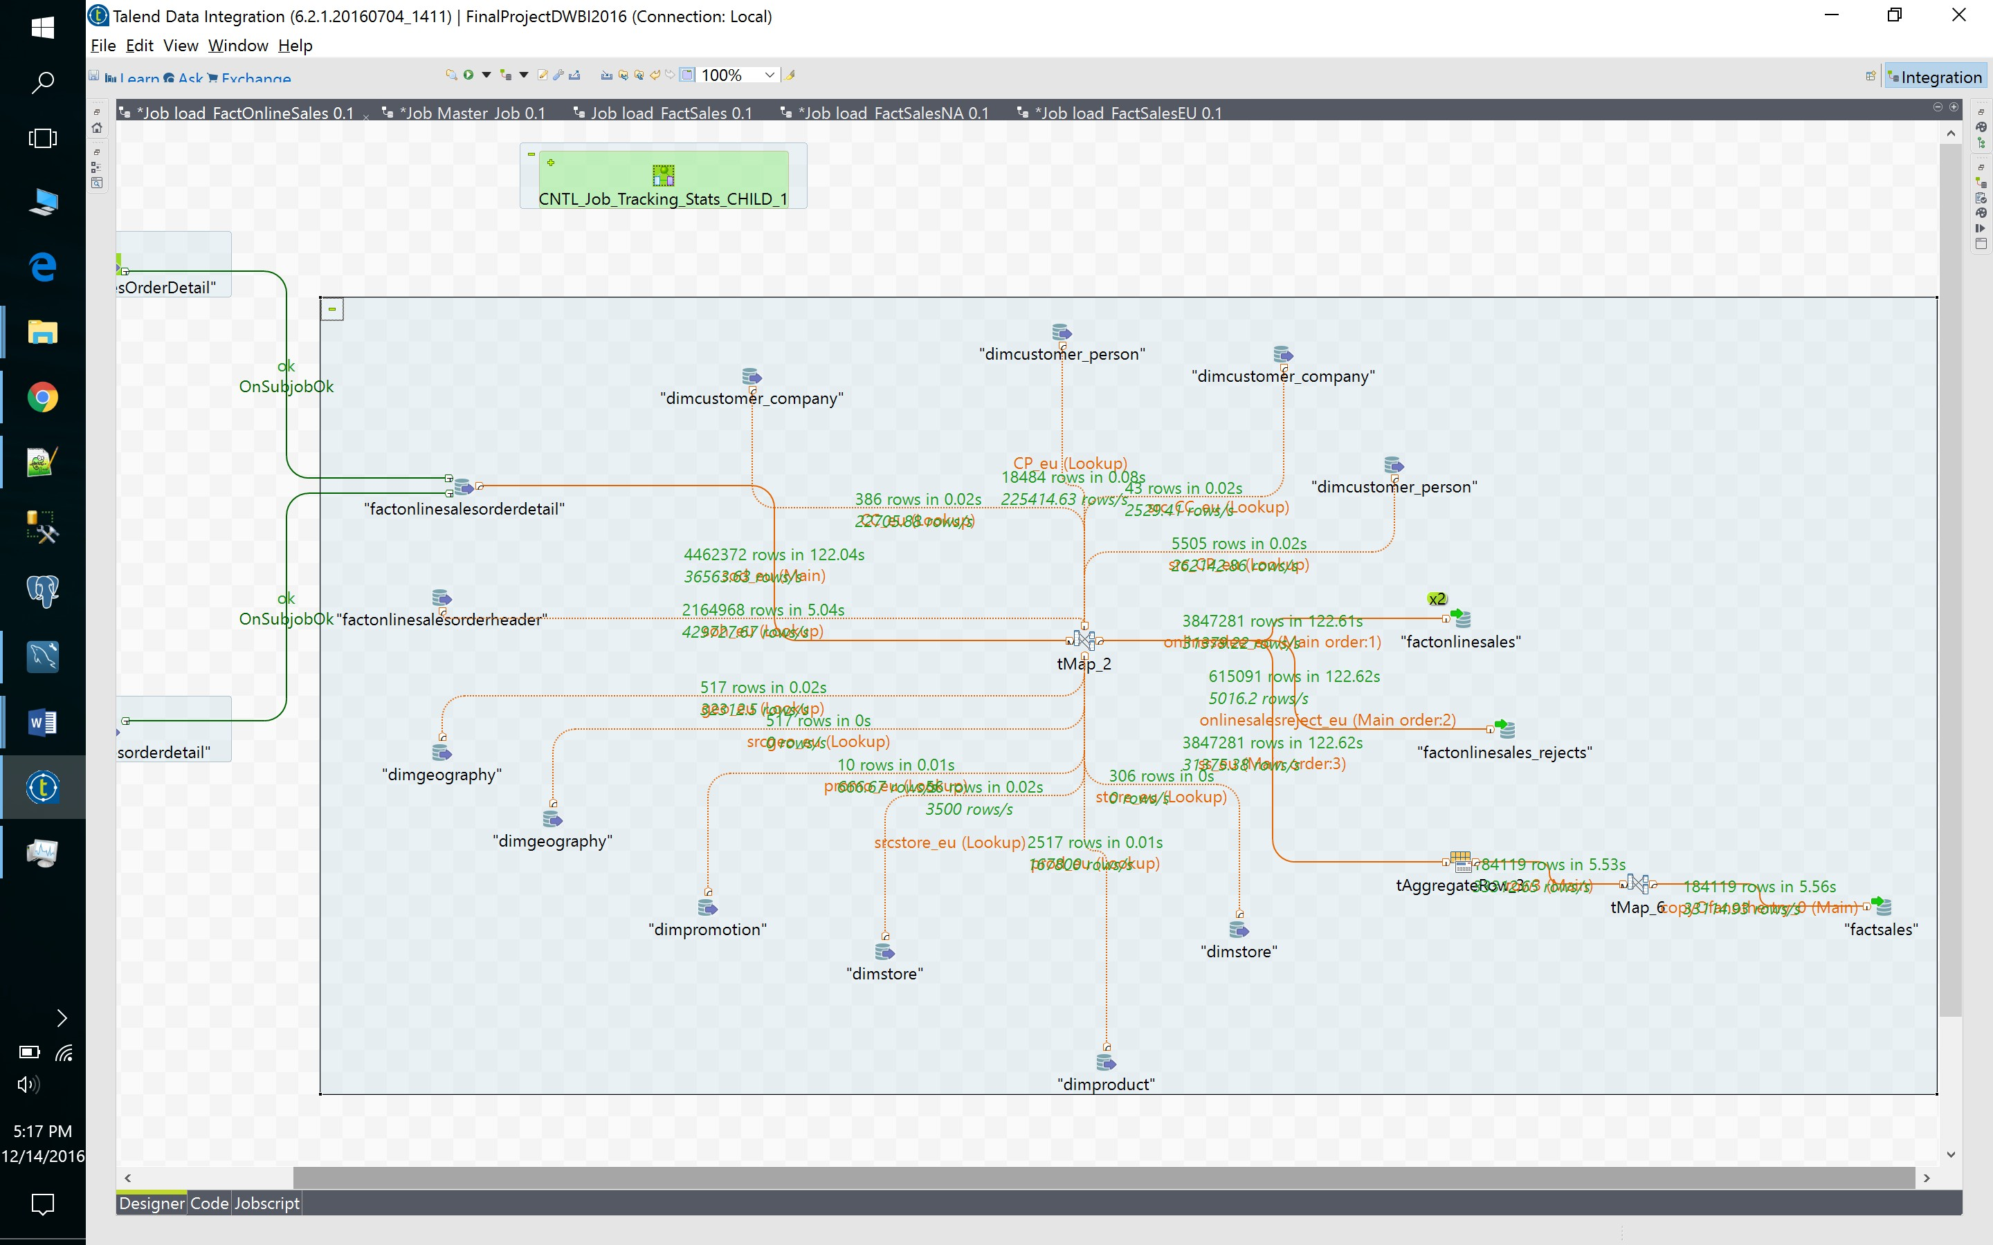

22. FactSales

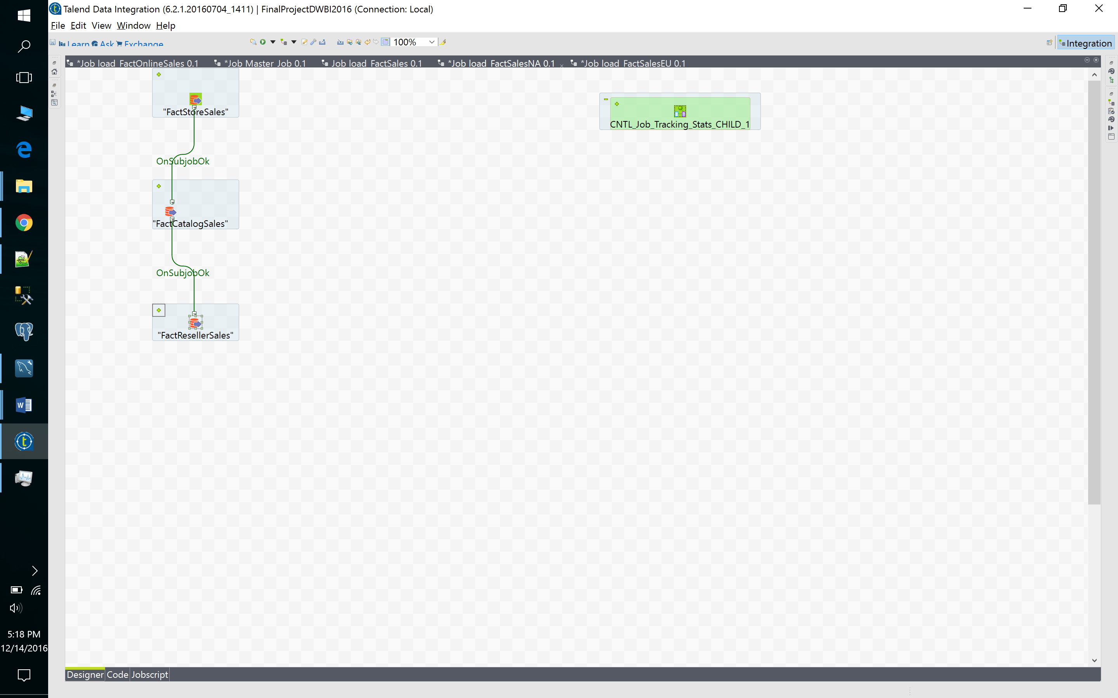

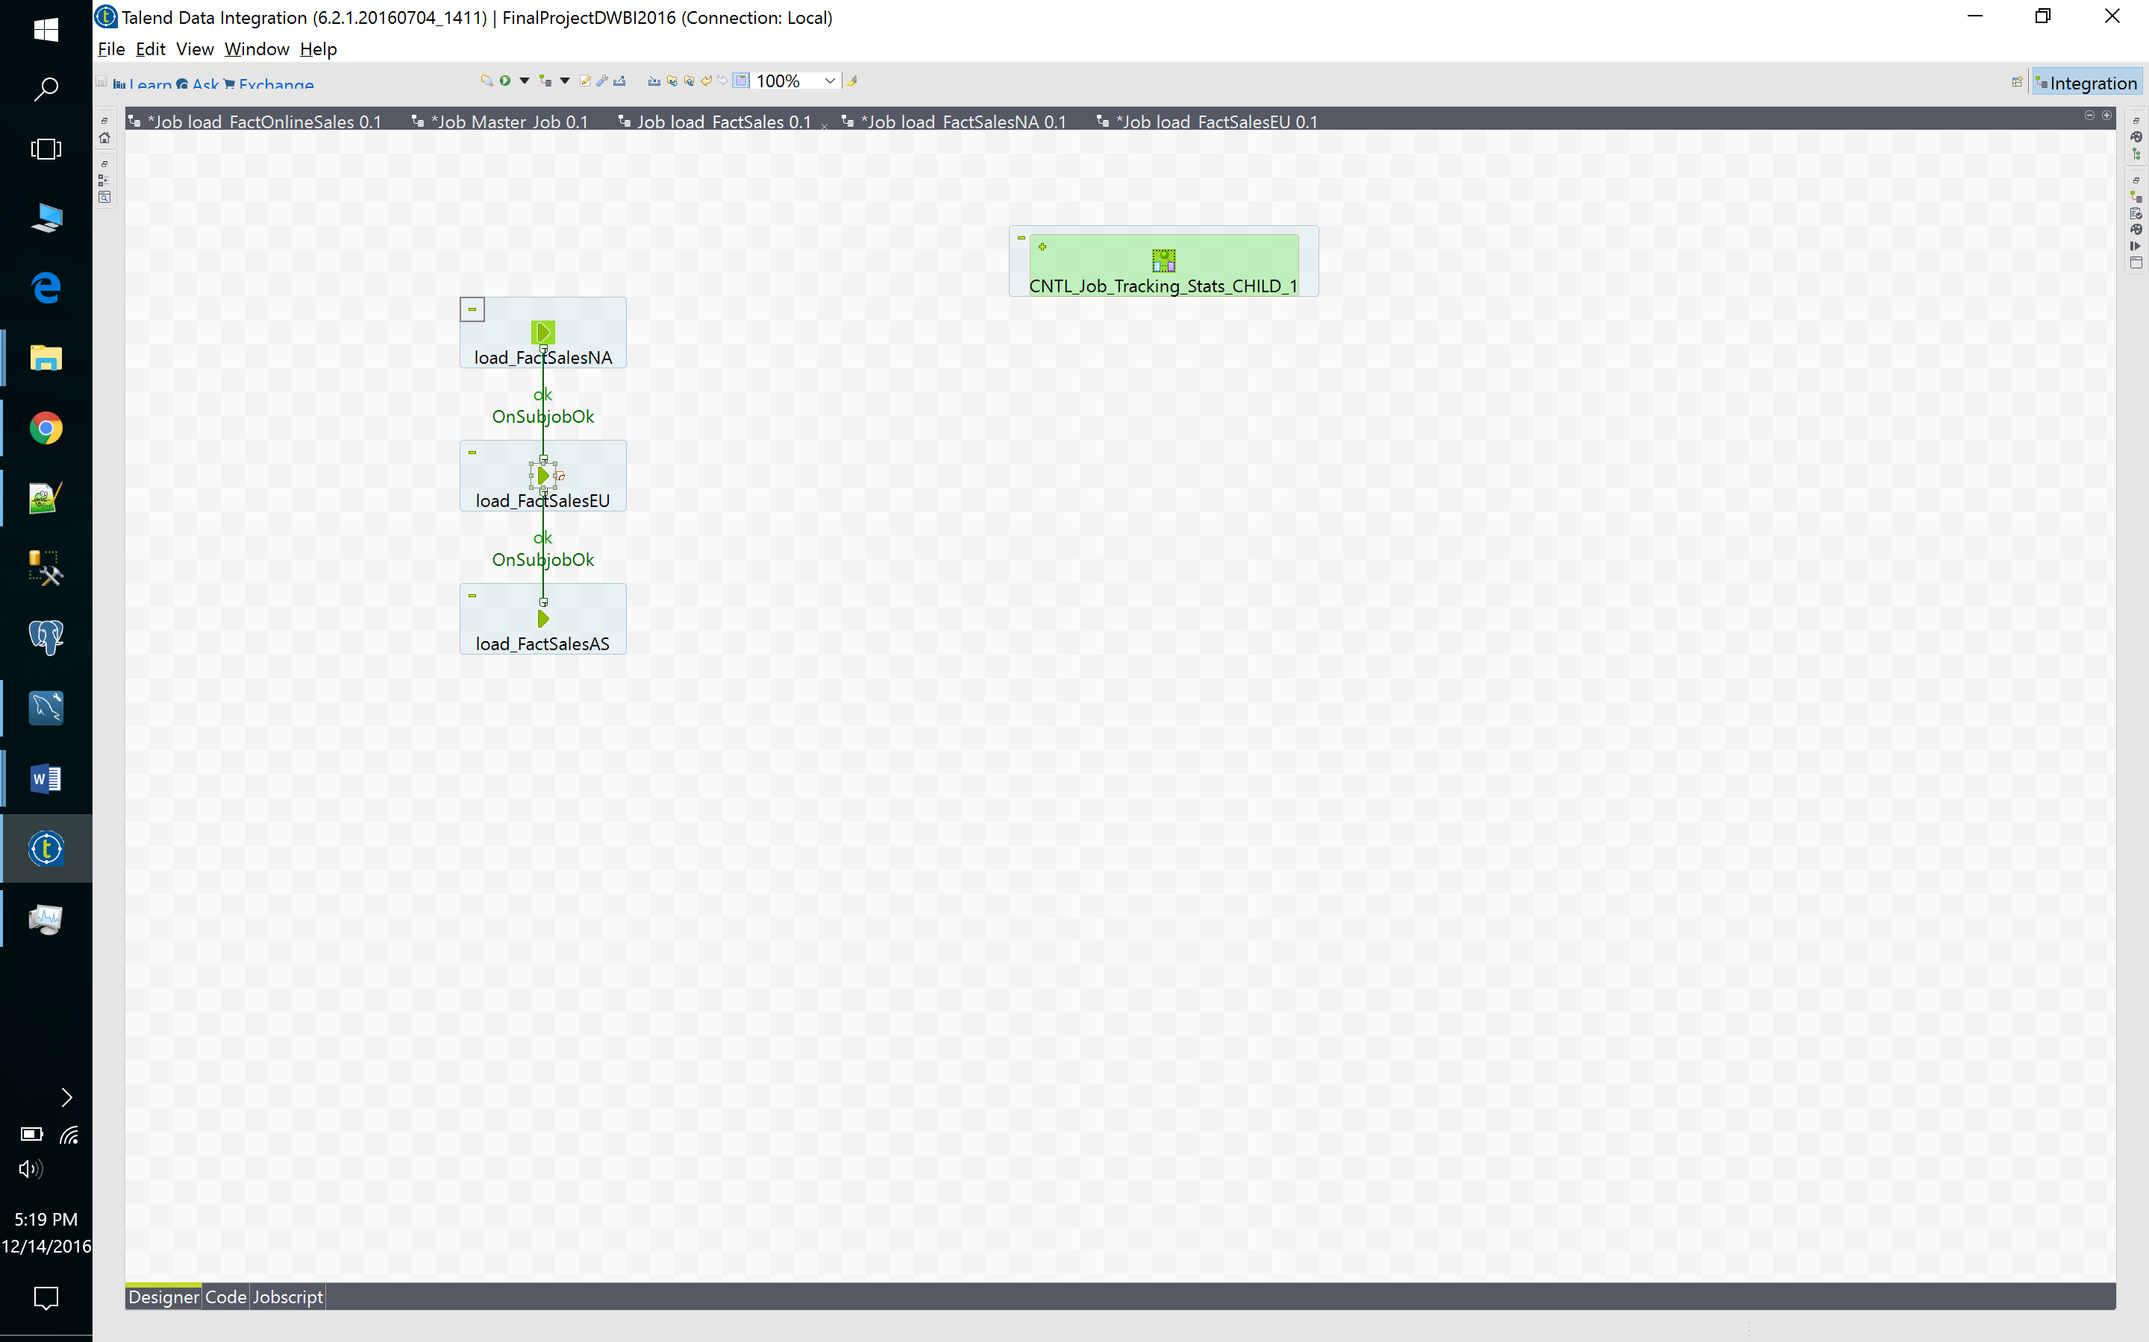

# Master Job Screenshot

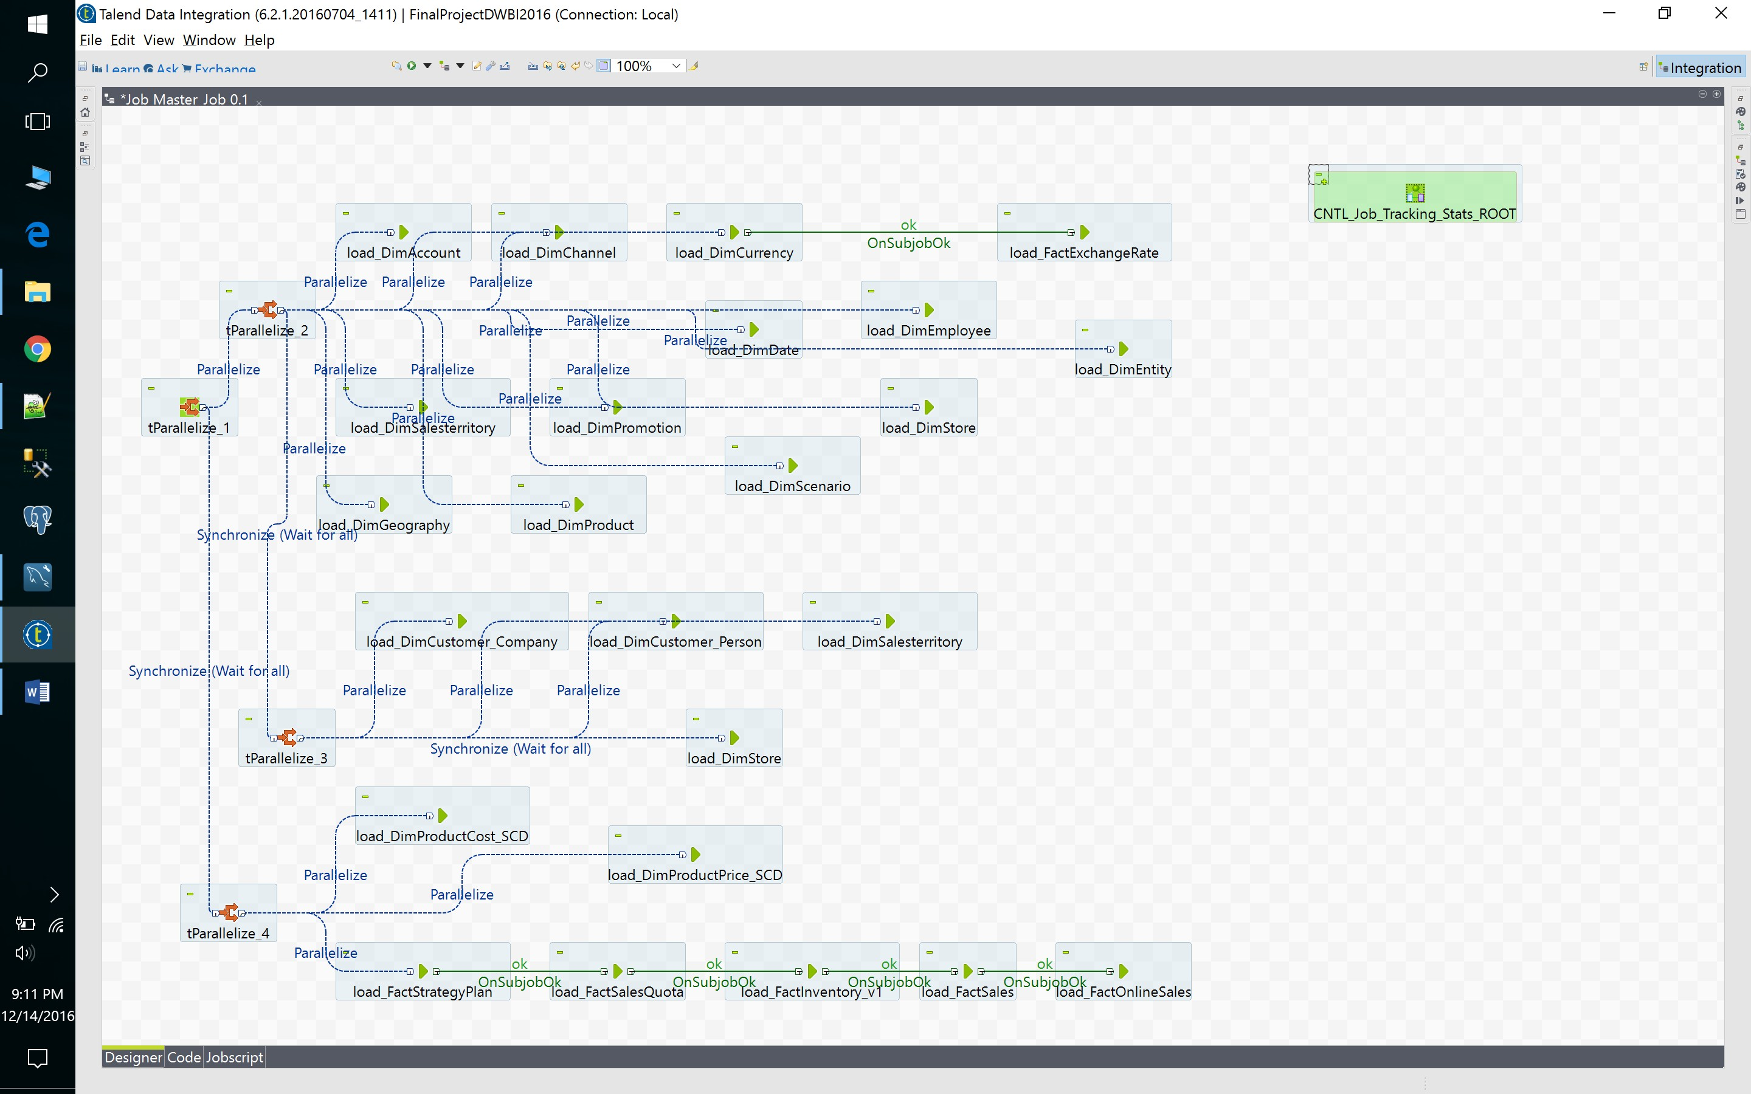

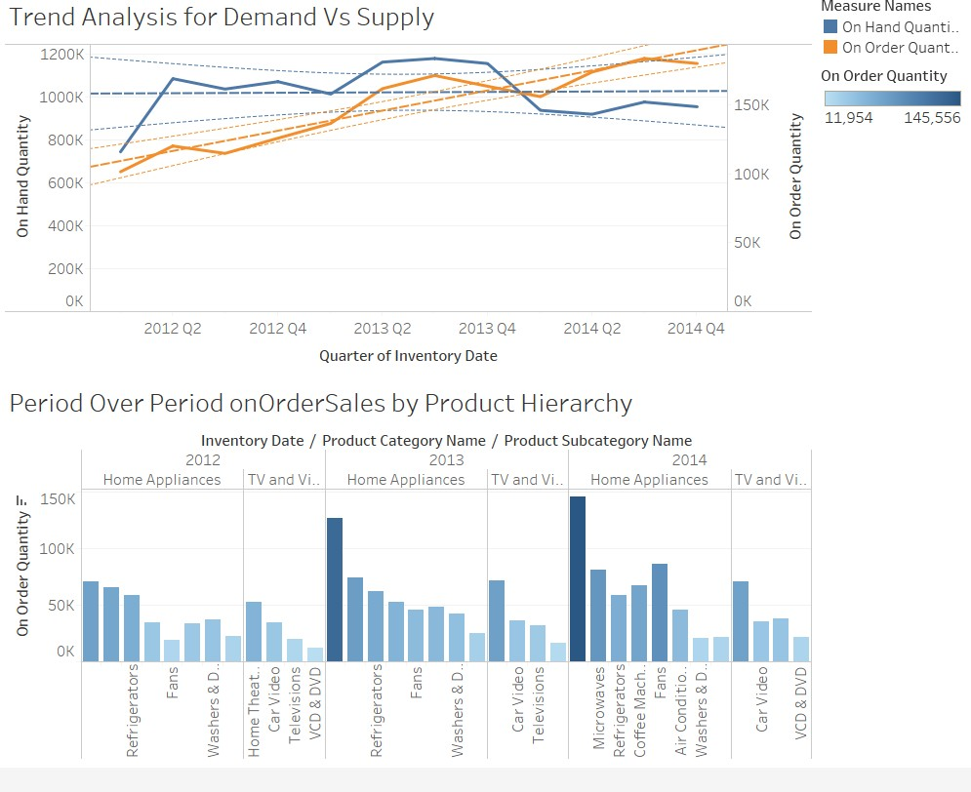**BI Dashboard Screenshots**

